Note:
In Oracle, you check constraints in USER_CONSTRAINTS.
In MySQL, there isn’t a USER_CONSTRAINTS table. Instead, MySQL stores all metadata in the INFORMATION_SCHEMA database.
For constraints, you can query:

📘 Check constraints in MySQL

1. Foreign Keys
SELECT *
FROM INFORMATION_SCHEMA.REFERENTIAL_CONSTRAINTS
WHERE CONSTRAINT_SCHEMA = 'your_database_name';

2. Check / Unique / Primary Key constraints
SELECT *
FROM INFORMATION_SCHEMA.TABLE_CONSTRAINTS
WHERE TABLE_SCHEMA = 'your_database_name';

3. Detailed columns under constraints
SELECT *
FROM INFORMATION_SCHEMA.KEY_COLUMN_USAGE
WHERE TABLE_SCHEMA = 'your_database_name';

✅ So the equivalent of Oracle’s USER_CONSTRAINTS in MySQL is mainly:
- INFORMATION_SCHEMA.TABLE_CONSTRAINTS
- INFORMATION_SCHEMA.KEY_COLUMN_USAGE
- INFORMATION_SCHEMA.REFERENTIAL_CONSTRAINTS

If you just want a simple query in MySQL to display the constraint name and constraint type for the Employees table, you can use:
SELECT
CONSTRAINT_NAME,
CONSTRAINT_TYPE
FROM INFORMATION_SCHEMA.TABLE_CONSTRAINTS
WHERE TABLE_SCHEMA = 'your_database_name'
AND TABLE_NAME = 'Employees';

Example
Let’s assume your Employees table was created like this:
CREATE TABLE Employees (
emp_id INT PRIMARY KEY,
name VARCHAR(100),
department VARCHAR(50),
email VARCHAR(100) UNIQUE,
salary DECIMAL,
CONSTRAINT fk_dept FOREIGN KEY (department) REFERENCES Departments(department)
);
Now, if you run:
SELECT
CONSTRAINT_NAME,
CONSTRAINT_TYPE
FROM INFORMATION_SCHEMA.TABLE_CONSTRAINTS
WHERE TABLE_SCHEMA = 'your_database_name'
AND TABLE_NAME = 'Employees';

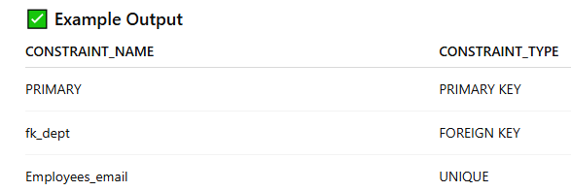

To see constraint name, type, and the column(s) they apply to for the Employees table in MySQL, you can use this query:
SELECT
tc.CONSTRAINT_NAME,
tc.CONSTRAINT_TYPE,
kcu.COLUMN_NAME
FROM INFORMATION_SCHEMA.TABLE_CONSTRAINTS tc
JOIN INFORMATION_SCHEMA.KEY_COLUMN_USAGE kcu
ON tc.CONSTRAINT_NAME = kcu.CONSTRAINT_NAME
AND tc.TABLE_SCHEMA = kcu.TABLE_SCHEMA
AND tc.TABLE_NAME = kcu.TABLE_NAME
WHERE tc.TABLE_SCHEMA = 'your_database_name'
AND tc.TABLE_NAME = 'Employees';

